To install miniconda:

<https://docs.conda.io/en/latest/miniconda.html>

click on link to download windows 64bit version of the installer.

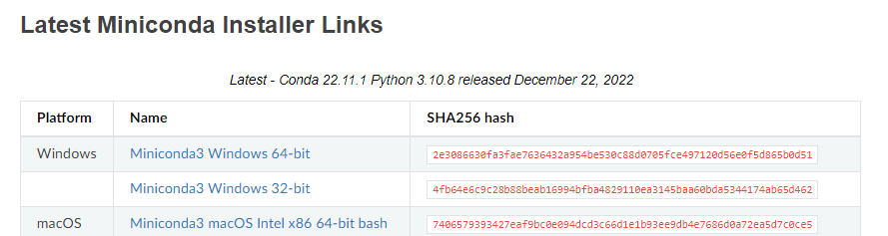

Run the installer. Make sure you run it locally (this should be the default).

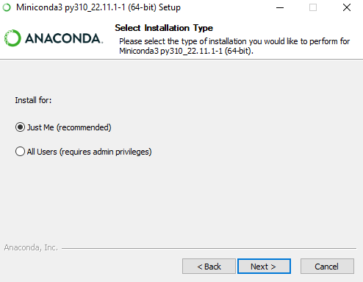

Finish installation using all the defaults

Click on start menu, open Anaconda Prompt

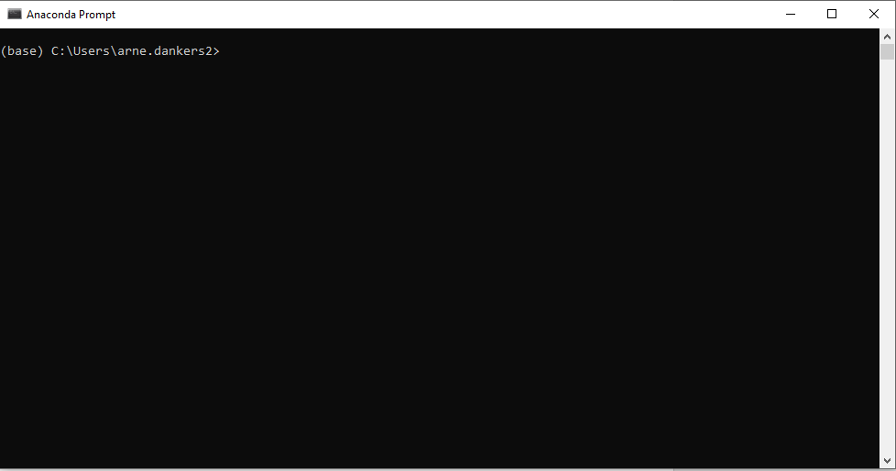

Create a new virtual environment where to download all the packages. To do this: at the prompttype in:

>>conda create -n enel441 python=3.9

Yu will be prompet to proceed, type ‘y’ for yes.

This creates a virtual environment called enel441.

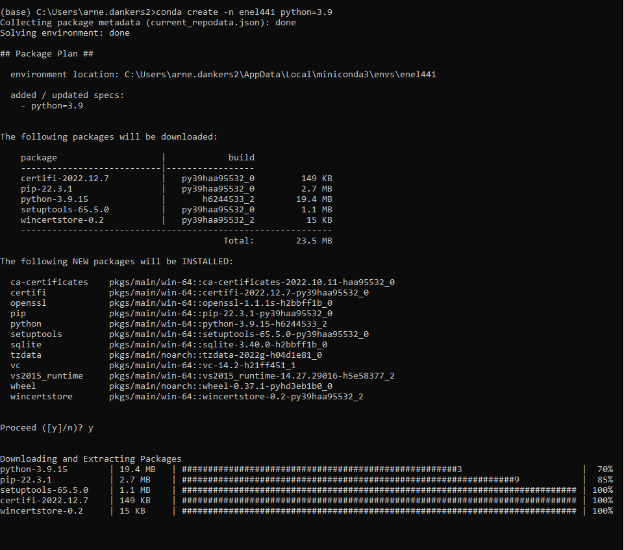

Now we will activate the environment:

>>conda activate enel441 

Note that the text in bracket preceding the prompt has changed. This indicates whach environment is active.

Now we will install the required packages.

>>conda install numpy jupyter scipy matplotlib

You will be asked to confirm the installation. Type ‘y’ in the prompt.

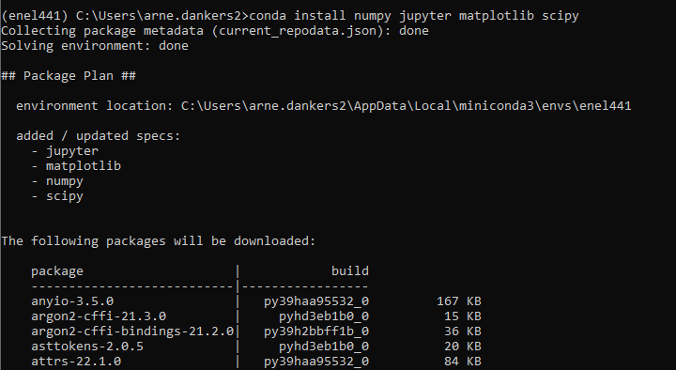

Plus more text will appear bewlow this.

Wait until you see the following text in the window:

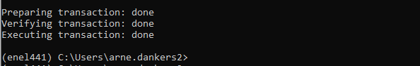

Now install control package:

>>conda install -c conda-forge control

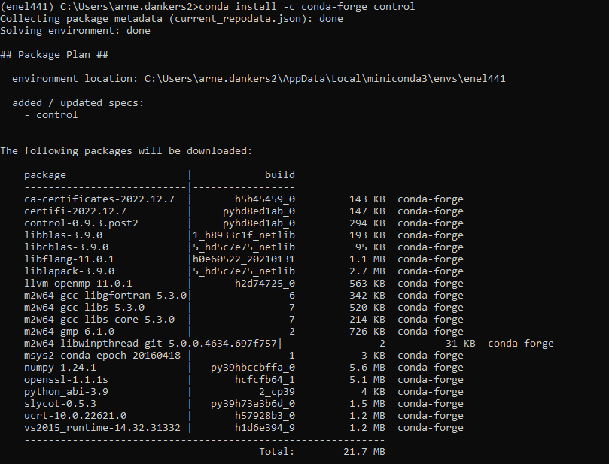

It will print a message about upgradge/downgrading some packages. Just type ‘y’ to accept.

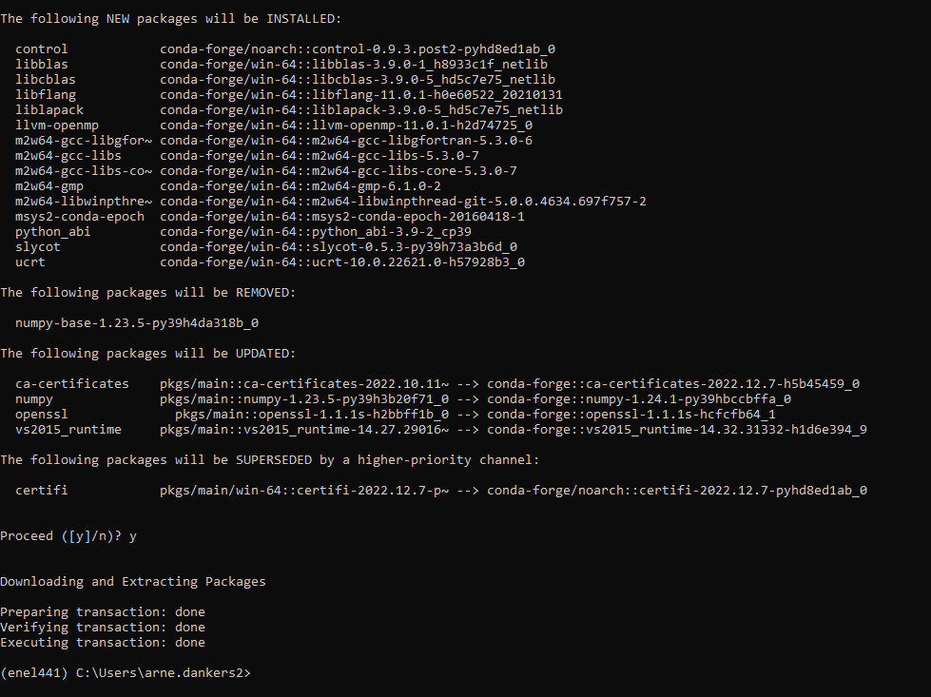

Start a notebook.

Type

>>jupyter notebook

This will open a windown in your browser. Or it might open a new browers. The browser page will look like:

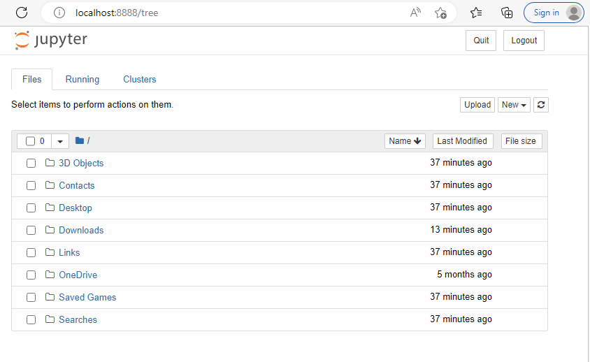

Make a folder. I made one on the desktop called ENEL441, then I made a nother folder in ENEL441 called Lab1. Use the mouse to click to the floder you wish to store your notebook. :

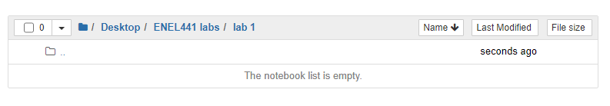

Then click on the ‘New” button:

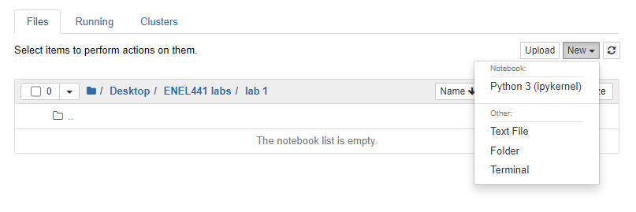

And select Python 3 (ipykernel)

This should start a new notebook. :

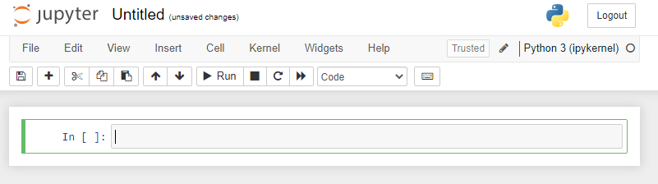

Click on ‘File’ then ‘save as’ to rename and save the file.

You are now ready to run python code in the notebook!